

THE MAT YOUTH WRESTLING TOURNAMENT

# Sunday December 22nd, 2024

# Wrestling to start at 9:30am

Menasha High School Fieldhouse

Enter through Door #15

420 7th St Menasha

(Main Parking Lot on 8th St.)

FOLKSTYLE TOURNAMENT

Grades PreK-8th

**Boys Divisions:** Pre-K - K, 1st - 2nd, 3rd - 4th, 5th - 6th, 7th - 8th

**Girls Divisions:** K-2nd, 3rd - 4th, 5th -6th, 7th - 8th (subject to change based on numbers)

4 person round robin bracketing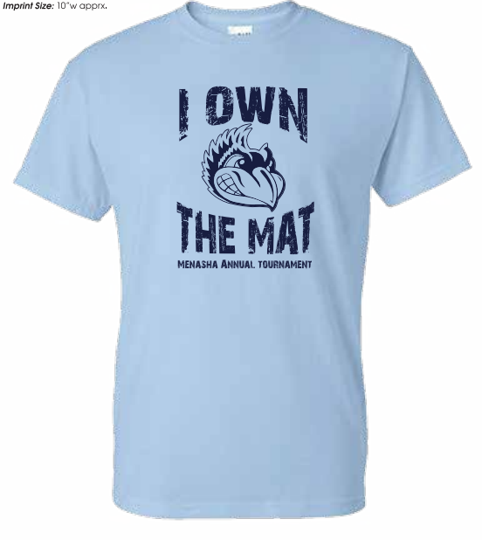

3--1 minute periods for Prek-6

3 -- 90 second periods for 7th - 8th

NO USA CARD REQUIRED

WIAA refs on most mats

**EVERYONE WILL WRESTLE ON FULL MATS!!!**

## Register on Trackwrestling.com

## Registration will close 5:00 pm on December 20th or when full

**Last year we sold out a week before the tournament!!!!**

350 wrestler limit

Entry Fee $25.00

**Walk-ins not allowed No Refunds**

Awards:

Trophy (limited supply) or first place medal, and a T-shirt for 1st place

Custom medals for 2nd-4th

Pins will be handed out to wrestlers that Pin their opponent

*TEAM TROPHY 1st-3rd place*

*$*25 entry for each 10 wrestler team

Weigh-ins will be Sunday Dec 22nd from 7am to 830am. Must be within 2 lbs of the registered weight. Brackets may be adjusted based on weight from weigh in, if over the 2 pound allowance.

Anyone late for weigh-ins will be scratched from the tournament with no refund.

**Admissions**

$5.00 12 years and up

Concessions available all day cash or credit card accepted

## Contact: Jamie Petersen Johnson (920) 540-5273

## 