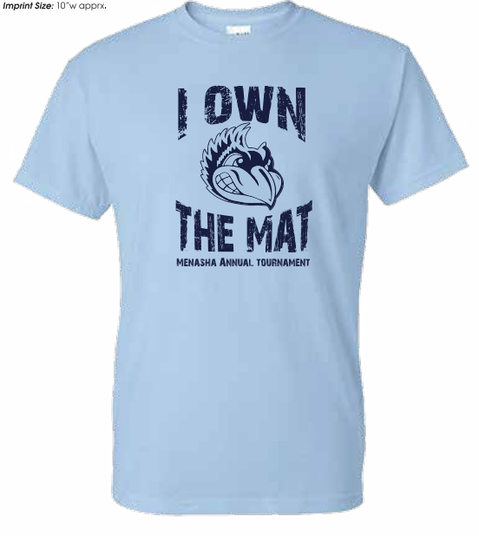

THE MAT YOUTH WRESTLING TOURNAMENT

Sunday December 21st, 2025

Wrestling to start at 9:30am
Menasha High School Fieldhouse
Enter through Door #15
420 7th St Menasha
(Main Parking Lot on 8th St.)

FOLKSTYLE TOURNAMENT
Grades PreK-8th
Boys Divisions: Pre-K - K, 1st - 2nd, 3rd - 4th, 5th - 6th, 7th - 8th
Girls Divisions: K-2nd, 3rd - 4th, 5th -6th, 7th - 8th (subject to change based on numbers)

4 person round robin bracketing
3--1 minute periods for Prek-6
3 -- 90 second periods for 7th - 8th
NO USA CARD REQUIRED
WIAA refs on most mats
EVERYONE WILL WRESTLE ON FULL MATS!!!

Register on USA Bracketing

Registration will close 5:00 pm on December 20th or when full
Last year we sold out a week before the tournament!!!!
325 wrestler limit
Entry Fee $25.00
Walk-ins not allowed No Refunds

Awards
First place medal, and a T-shirt for 1st place
Custom medals for 2nd-4th
Pins will be handed out to wrestlers that Pin their opponent

Weigh-ins will be Sunday Dec 21st from 7am to 800am. Must be within 2 lbs of the registered weight. Brackets may be adjusted based on weight from weigh in, if over or under the 2 pound allowance.
Anyone late for weigh-ins will be scratched from the tournament with no refund.

Admissions
$5.00 - 12 years and up

Concessions available all day cash or credit card accepted

Contact: Jamie Petersen Johnson (920) 540-5273 or mwclub1990@gmail.com

